Mixed-Shape Repeated Composite Solids

Definition
# Source: AI Source: Provided by: [Data Path: Persons Table -> ID Column: 1, Name_En Column: Motasem Essam] -> From: [ChatGPT] on [7/25/2026]
Mixed-Shape Repeated Composite Solids are three-dimensional geometric structures formed by combining two or more different types of geometric solids in a repeated arrangement or pattern.
These structures contain multiple components that may be repeated in equal or varying dimensions. The components can include cubes, rectangular prisms, triangular prisms, cylinders, cones, pyramids, spheres, and hemispheres.
They may be arranged linearly, vertically, horizontally, radially, in layers, or in more complex configurations.

Simple Definition
# Source: AI Source: Provided by: [Data Path: Persons Table -> ID Column: 1, Name_En Column: Motasem Essam] -> From: [ChatGPT] on [7/25/2026]
A mixed-shape repeated composite solid is a three-dimensional structure made by repeatedly combining different types of geometric solids.

Geometric Representation
# Source: AI Source: Provided by: [Data Path: Persons Table -> ID Column: 1, Name_En Column: Motasem Essam] -> From: [ChatGPT] on [7/25/2026]
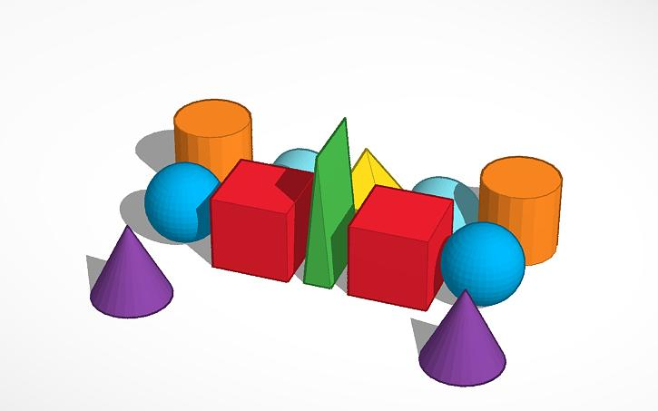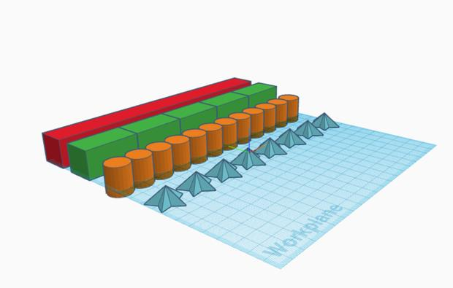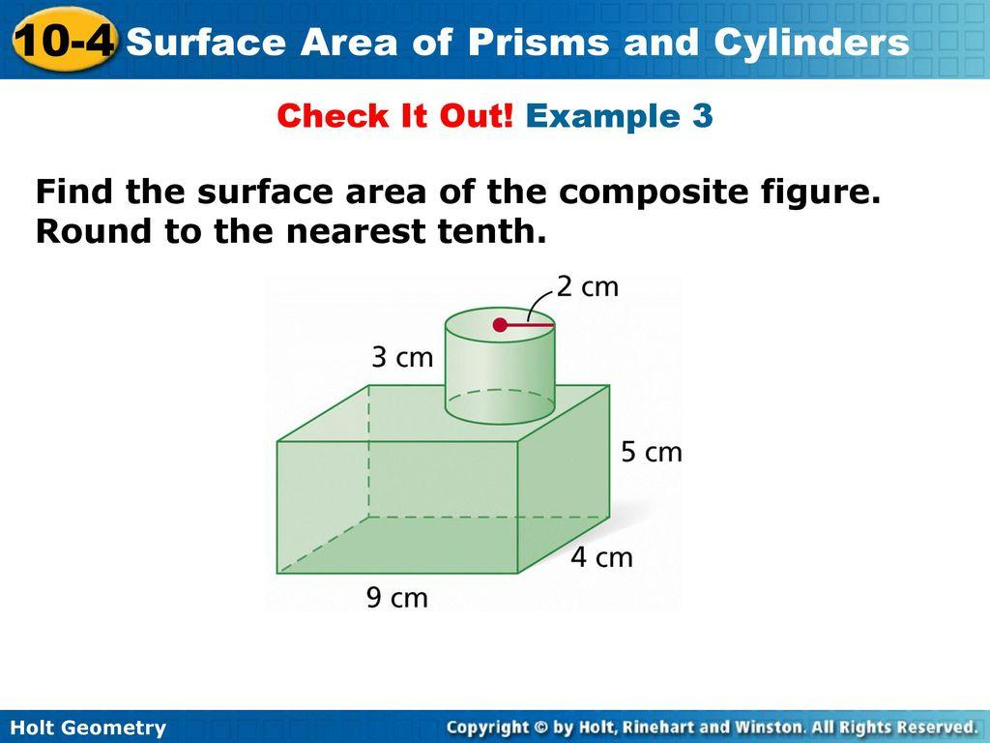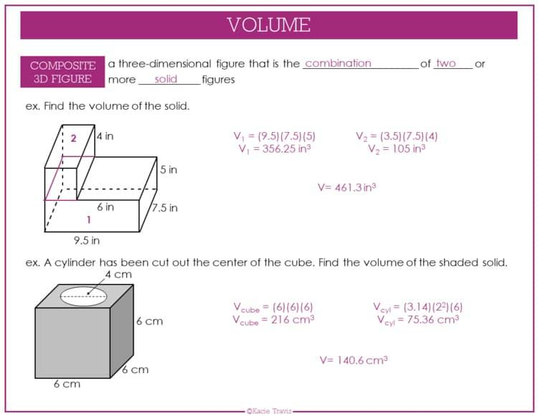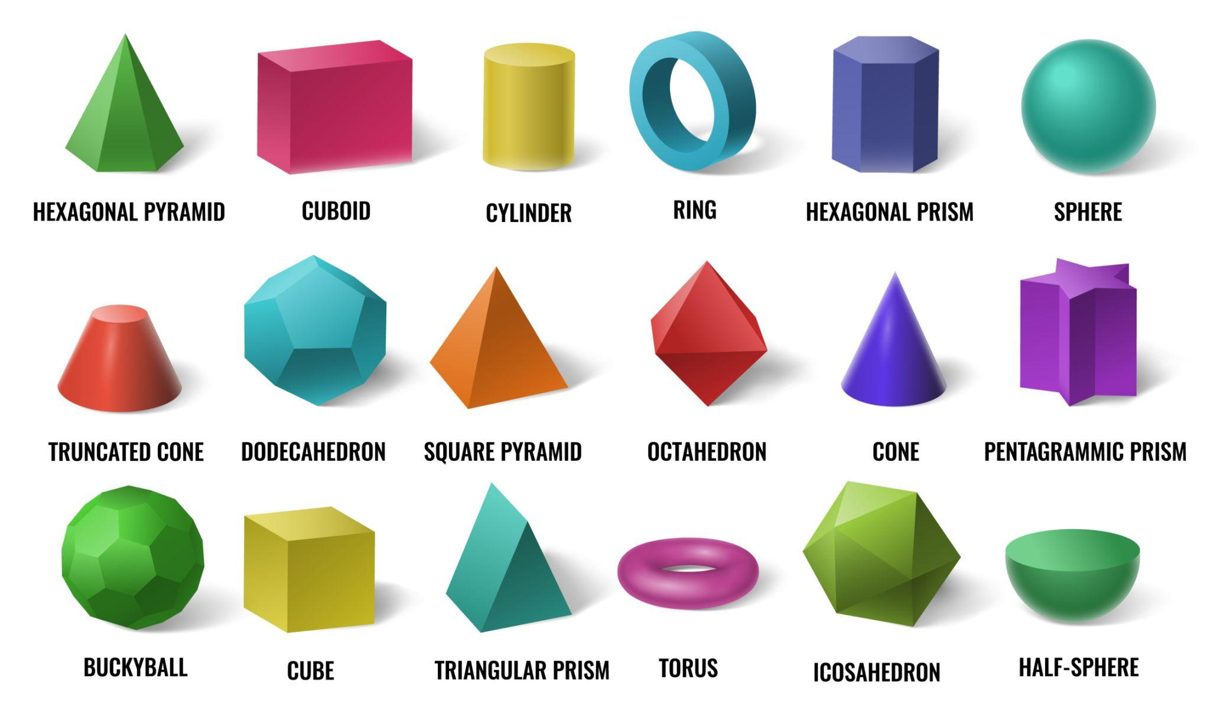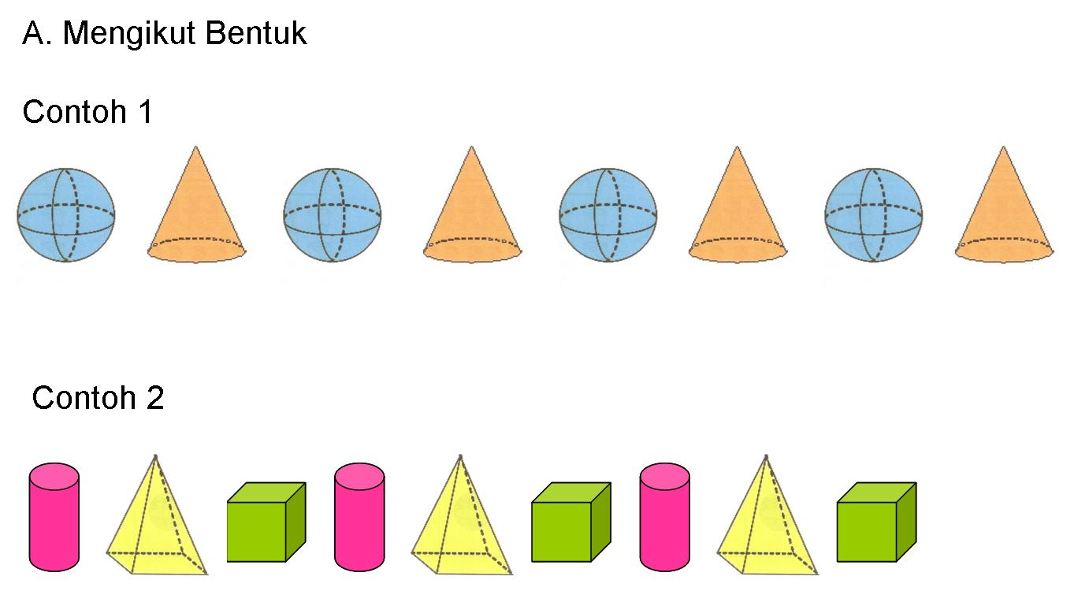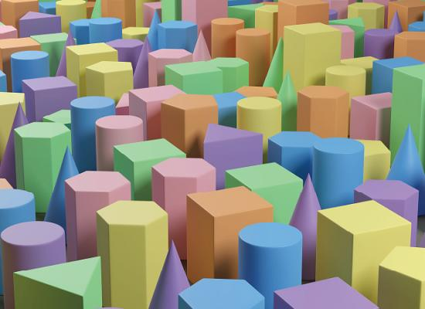
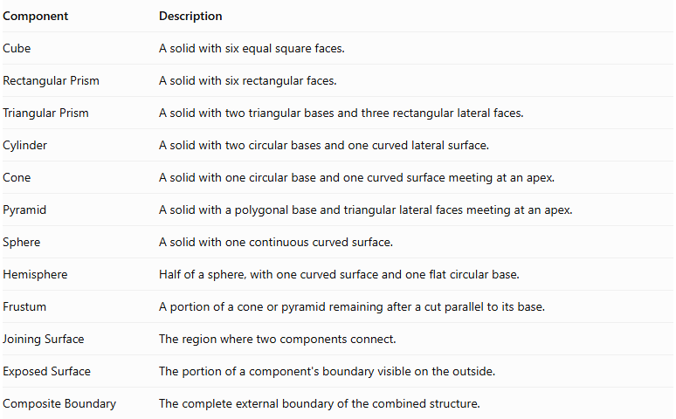
Component | Description
Cube | A solid with six equal square faces.
Rectangular Prism | A solid with six rectangular faces.
Triangular Prism | A solid with two triangular bases and three rectangular lateral faces.
Cylinder | A solid with two circular bases and one curved lateral surface.
Cone | A solid with one circular base and one curved surface meeting at an apex.
Pyramid | A solid with a polygonal base and triangular lateral faces meeting at an apex.
Sphere | A solid with one continuous curved surface.
Hemisphere | Half of a sphere, with one curved surface and one flat circular base.
Frustum | A portion of a cone or pyramid remaining after a cut parallel to its base.
Joining Surface | The region where two components connect.
Exposed Surface | The portion of a component's boundary visible on the outside.
Composite Boundary | The complete external boundary of the combined structure.

Types of Mixed-Shape Repeated Composite Solids

Prism-Cylinder Repeated Composite Solids
# Source: AI Source: Provided by: [Data Path: Persons Table -> ID Column: 1, Name_En Column: Motasem Essam] -> From: [ChatGPT] on [7/25/2026]
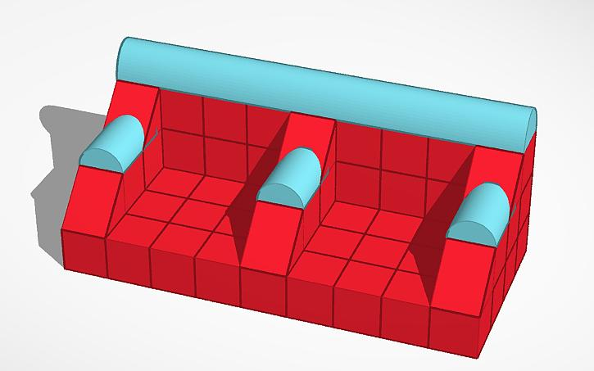
Structures formed by repeatedly combining prisms and cylinders.
- Rectangular prisms may support cylindrical components.
- Cylinders may be positioned on top of or beside prisms.
- Repeated units may have identical or different dimensions.
- Examples include repeated columns on rectangular bases.

Prism-Cone Repeated Composite Solids
# Source: AI Source: Provided by: [Data Path: Persons Table -> ID Column: 1, Name_En Column: Motasem Essam] -> From: [ChatGPT] on [7/25/2026]
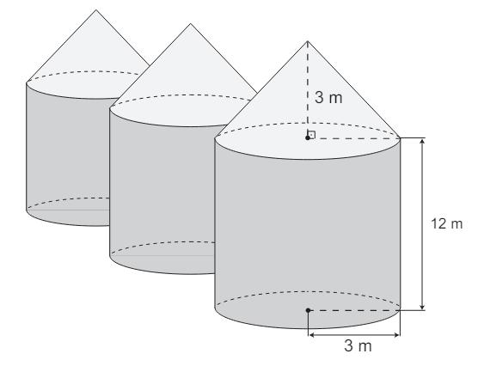
Structures formed by combining prisms and cones in a repeated pattern.
- Cones may be attached to prism surfaces through their circular bases.
- Multiple prism-cone units may be arranged in rows or layers.
- The cone bases may occupy only part of the prism's planar faces.

Prism-Sphere Repeated Composite Solids
# Source: AI Source: Provided by: [Data Path: Persons Table -> ID Column: 1, Name_En Column: Motasem Essam] -> From: [ChatGPT] on [7/25/2026]
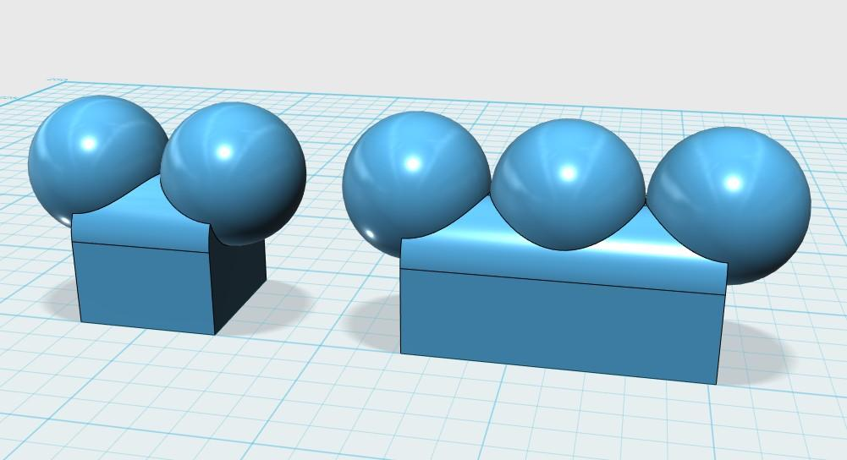
Structures formed by combining prisms and spheres.
- Spheres may be placed above, beside, or within prism-based components.
- Repeated units may have equal or different sphere radii.
- A complete sphere has no flat joining face, so contact with a prism may be point-based or partial unless the sphere is cut.

Prism-Pyramid Repeated Composite Solids
# Source: AI Source: Provided by: [Data Path: Persons Table -> ID Column: 1, Name_En Column: Motasem Essam] -> From: [ChatGPT] on [7/25/2026]
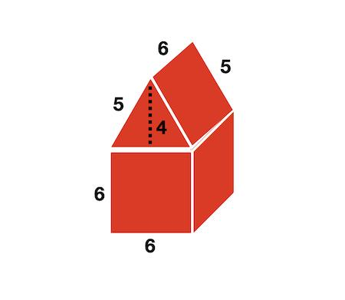
Structures formed by repeatedly combining prisms and pyramids.
- Pyramids may be attached to prism bases or faces.
- A pyramid can be placed on top of a prism with matching polygonal bases.
- Multiple units can form stepped or tower-like structures.

Cylinder-Cone Repeated Composite Solids
# Source: AI Source: Provided by: [Data Path: Persons Table -> ID Column: 1, Name_En Column: Motasem Essam] -> From: [ChatGPT] on [7/25/2026]
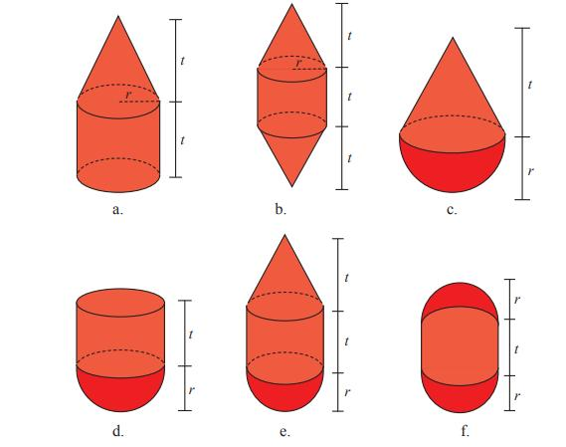
Structures formed by repeatedly combining cylinders and cones.
- Cones may be attached to cylinder bases.
- Multiple cylinder-cone units may be arranged vertically or horizontally.
- Coaxial arrangements can create repeated tapered structures.

Cylinder-Sphere Repeated Composite Solids
# Source: AI Source: Provided by: [Data Path: Persons Table -> ID Column: 1, Name_En Column: Motasem Essam] -> From: [ChatGPT] on [7/25/2026]

Structures formed by combining cylinders and spheres.
- Spheres may be positioned at cylinder ends or along their sides.
- Components may be arranged symmetrically around a common axis.
- Contact regions must be considered when calculating external surface area.

Cylinder-Hemisphere Repeated Composite Solids
# Source: AI Source: Provided by: [Data Path: Persons Table -> ID Column: 1, Name_En Column: Motasem Essam] -> From: [ChatGPT] on [7/25/2026]
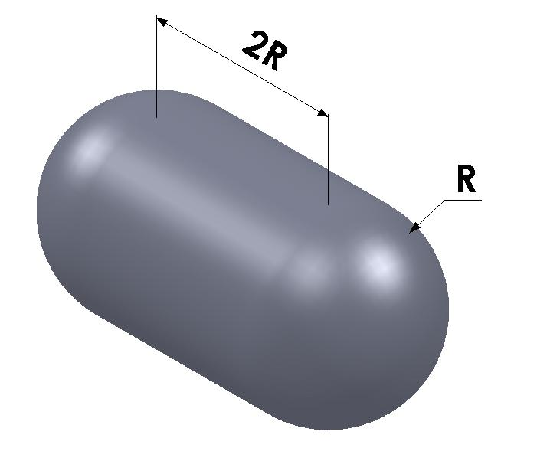
Structures formed by combining cylinders and hemispheres.
- Hemispheres may be attached to one or both ends of cylinders.
- Repeated units can form capsule-like structures.
- Matching circular bases can create complete face-to-face connections.

Cone-Pyramid Repeated Composite Solids
# Source: AI Source: Provided by: [Data Path: Persons Table -> ID Column: 1, Name_En Column: Motasem Essam] -> From: [ChatGPT] on [7/25/2026]
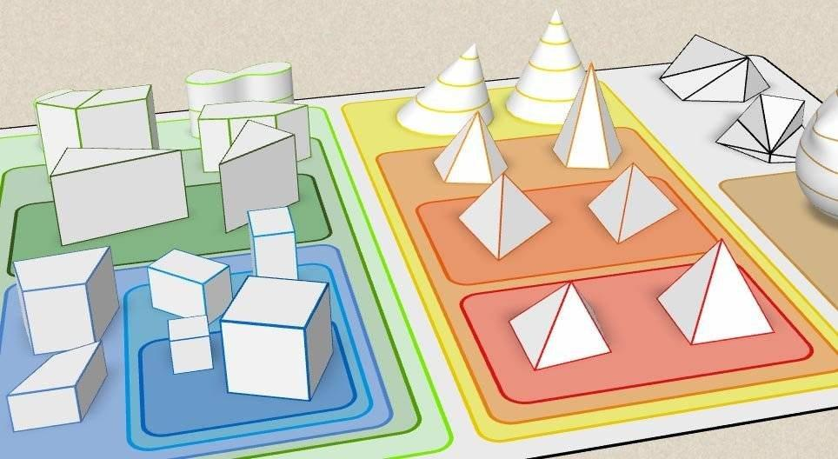
Structures formed by combining cones and pyramids.
- Components may be arranged in alternating sequences.
- The structures can combine curved and polygonal surfaces.
- They may be symmetrical or asymmetrical.

Cone-Sphere Repeated Composite Solids
# Source: AI Source: Provided by: [Data Path: Persons Table -> ID Column: 1, Name_En Column: Motasem Essam] -> From: [ChatGPT] on [7/25/2026]
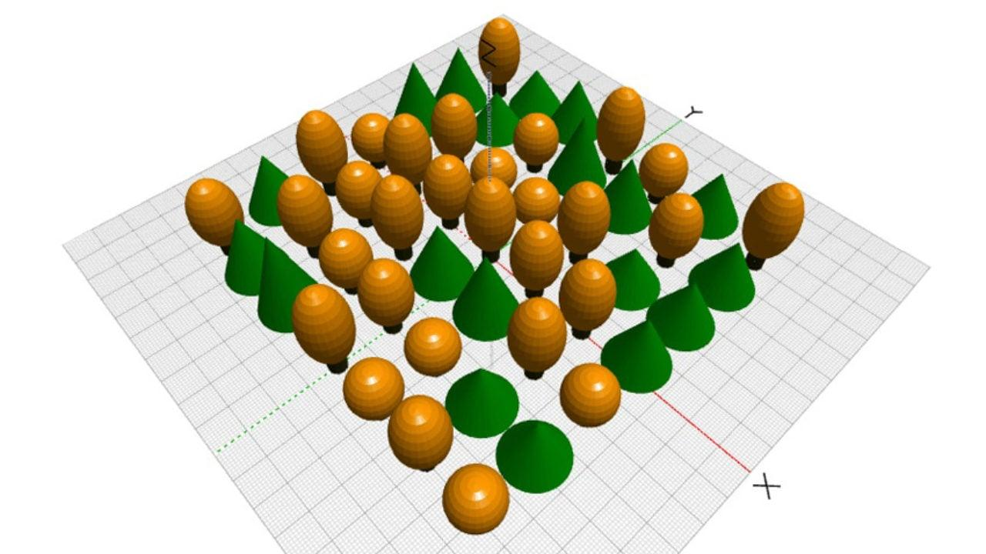
Structures formed by combining cones and spheres.
- Spheres may be positioned at cone bases or near their apexes.
- Components can be arranged in repeated rows or radial patterns.
- A complete sphere does not have a flat base, so connections depend on the actual contact geometry.

Pyramid-Sphere Repeated Composite Solids
# Source: AI Source: Provided by: [Data Path: Persons Table -> ID Column: 1, Name_En Column: Motasem Essam] -> From: [ChatGPT] on [7/25/2026]
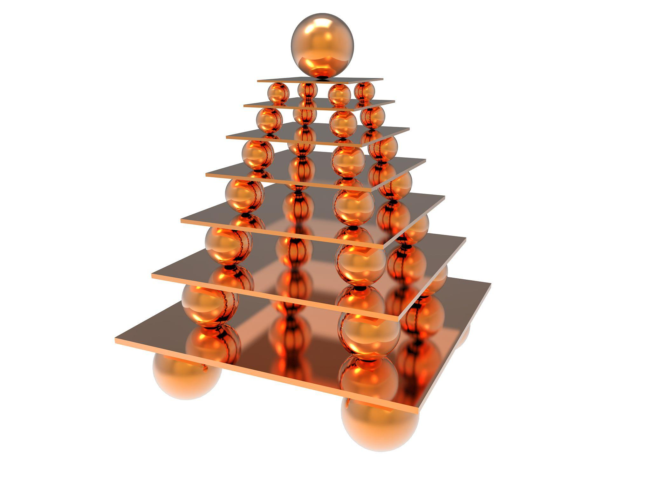
Structures formed by combining pyramids and spheres.
- Spheres may be positioned above or beside pyramids.
- Repeated units may have different pyramid types.
- Contact between a sphere and a pyramid requires consideration of the actual contact region.

Prism-Cylinder-Cone Repeated Composite Solids
# Source: AI Source: Provided by: [Data Path: Persons Table -> ID Column: 1, Name_En Column: Motasem Essam] -> From: [ChatGPT] on [7/25/2026]
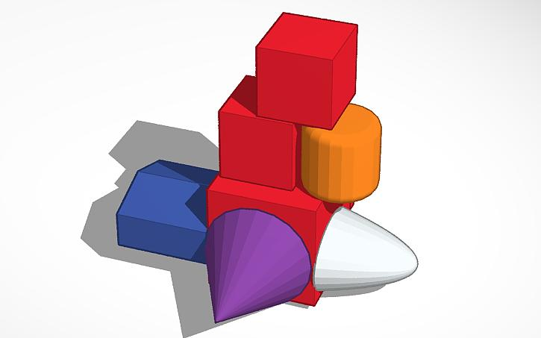
Structures formed by combining three different solid types: prisms, cylinders, and cones.
- Cylinders may be placed on prism bases.
- Cones may be attached to the upper circular bases of cylinders.
- Multiple identical units can form towers or repeated architectural structures.

Cylinder-Cone-Sphere Repeated Composite Solids
# Source: AI Source: Provided by: [Data Path: Persons Table -> ID Column: 1, Name_En Column: Motasem Essam] -> From: [ChatGPT] on [7/25/2026]
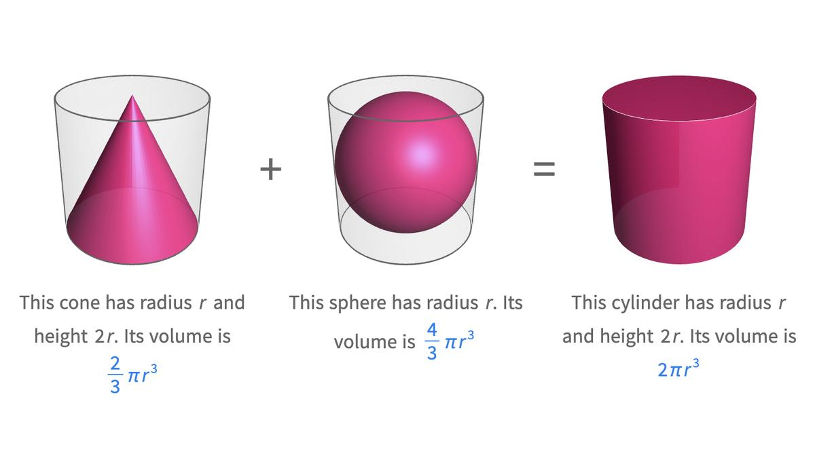
Structures formed by combining cylinders, cones, and spheres.
- The three components may form a repeated sequence.
- Their arrangement may be linear, vertical, or radial.
- The structure contains flat, conical, cylindrical, and spherical surfaces.

Multi-Type Repeated Composite Solids
# Source: AI Source: Provided by: [Data Path: Persons Table -> ID Column: 1, Name_En Column: Motasem Essam] -> From: [ChatGPT] on [7/25/2026]
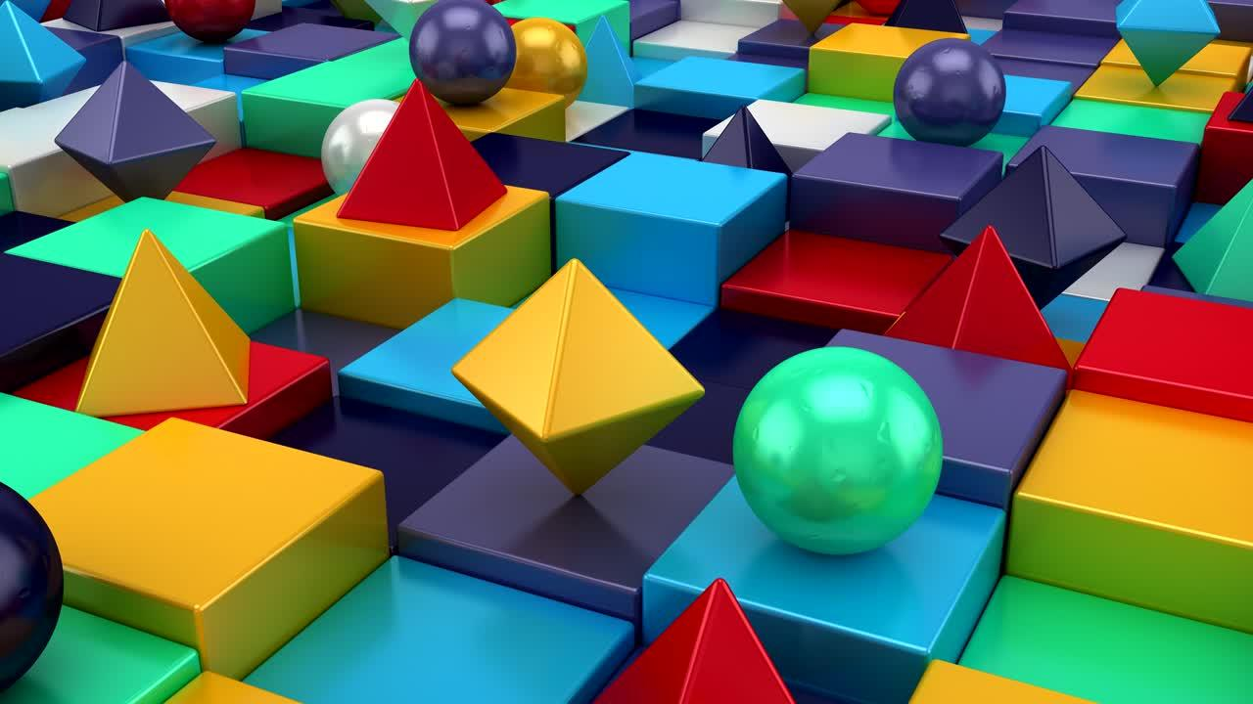
Structures formed by combining three or more different categories of solids.
- May include prisms, cylinders, cones, pyramids, spheres, and hemispheres.
- Components may repeat in complex patterns.
- The overall structure may be symmetrical, asymmetrical, layered, or irregular.

Classification by Component Types

By Number of Different Solid Types
# Source: AI Source: Provided by: [Data Path: Persons Table -> ID Column: 1, Name_En Column: Motasem Essam] -> From: [ChatGPT] on [7/25/2026]
- Two-Type Repeated Composite Solids: Contain two different categories of geometric solids.
- Three-Type Repeated Composite Solids: Contain three different categories.
- Four-Type Repeated Composite Solids: Contain four different categories.
- Multi-Type Repeated Composite Solids: Contain five or more different categories.

By Component Combination
# Source: AI Source: Provided by: [Data Path: Persons Table -> ID Column: 1, Name_En Column: Motasem Essam] -> From: [ChatGPT] on [7/25/2026]
- Prism-Cylinder Combination: Repeated units containing prisms and cylinders.
- Prism-Cone Combination: Repeated units containing prisms and cones.
- Prism-Sphere Combination: Repeated units containing prisms and spheres.
- Prism-Pyramid Combination: Repeated units containing prisms and pyramids.
- Cylinder-Cone Combination: Repeated units containing cylinders and cones.
- Cylinder-Sphere Combination: Repeated units containing cylinders and spheres.
- Cone-Pyramid Combination: Repeated units containing cones and pyramids.
- Cone-Sphere Combination: Repeated units containing cones and spheres.
- Pyramid-Sphere Combination: Repeated units containing pyramids and spheres.
- Multiple-Shape Combination: Repeated units containing three or more different solid types.

By Component Repetition
# Source: AI Source: Provided by: [Data Path: Persons Table -> ID Column: 1, Name_En Column: Motasem Essam] -> From: [ChatGPT] on [7/25/2026]
- Identical Component Repetition: The same component types and dimensions are repeated.
- Same-Type Different-Size Repetition: The same solid types are repeated with varying dimensions.
- Alternating Component Repetition: Different solid types appear in an alternating sequence.
- Mixed Component Repetition: Different component types appear in a recurring combination.
- Uniform Repetition: Repeated units have consistent dimensions and spacing.
- Non-Uniform Repetition: Repeated units vary in dimensions or spacing.

Classification by Arrangement
# Source: AI Source: Provided by: [Data Path: Persons Table -> ID Column: 1, Name_En Column: Motasem Essam] -> From: [ChatGPT] on [7/25/2026]
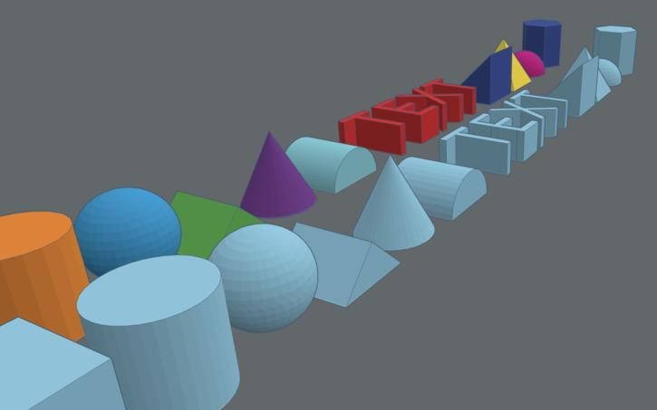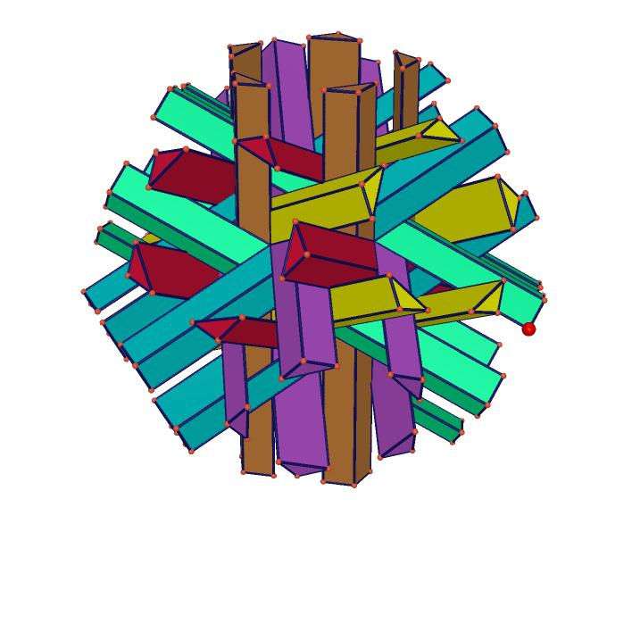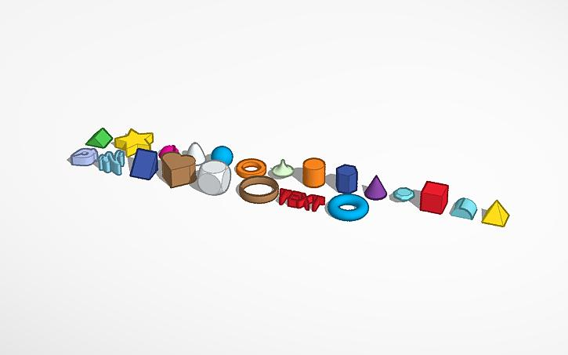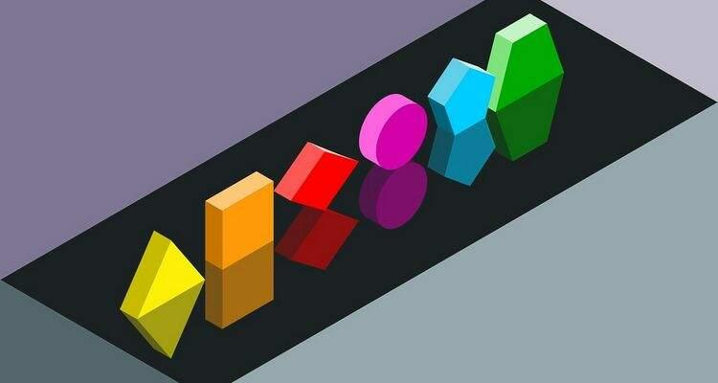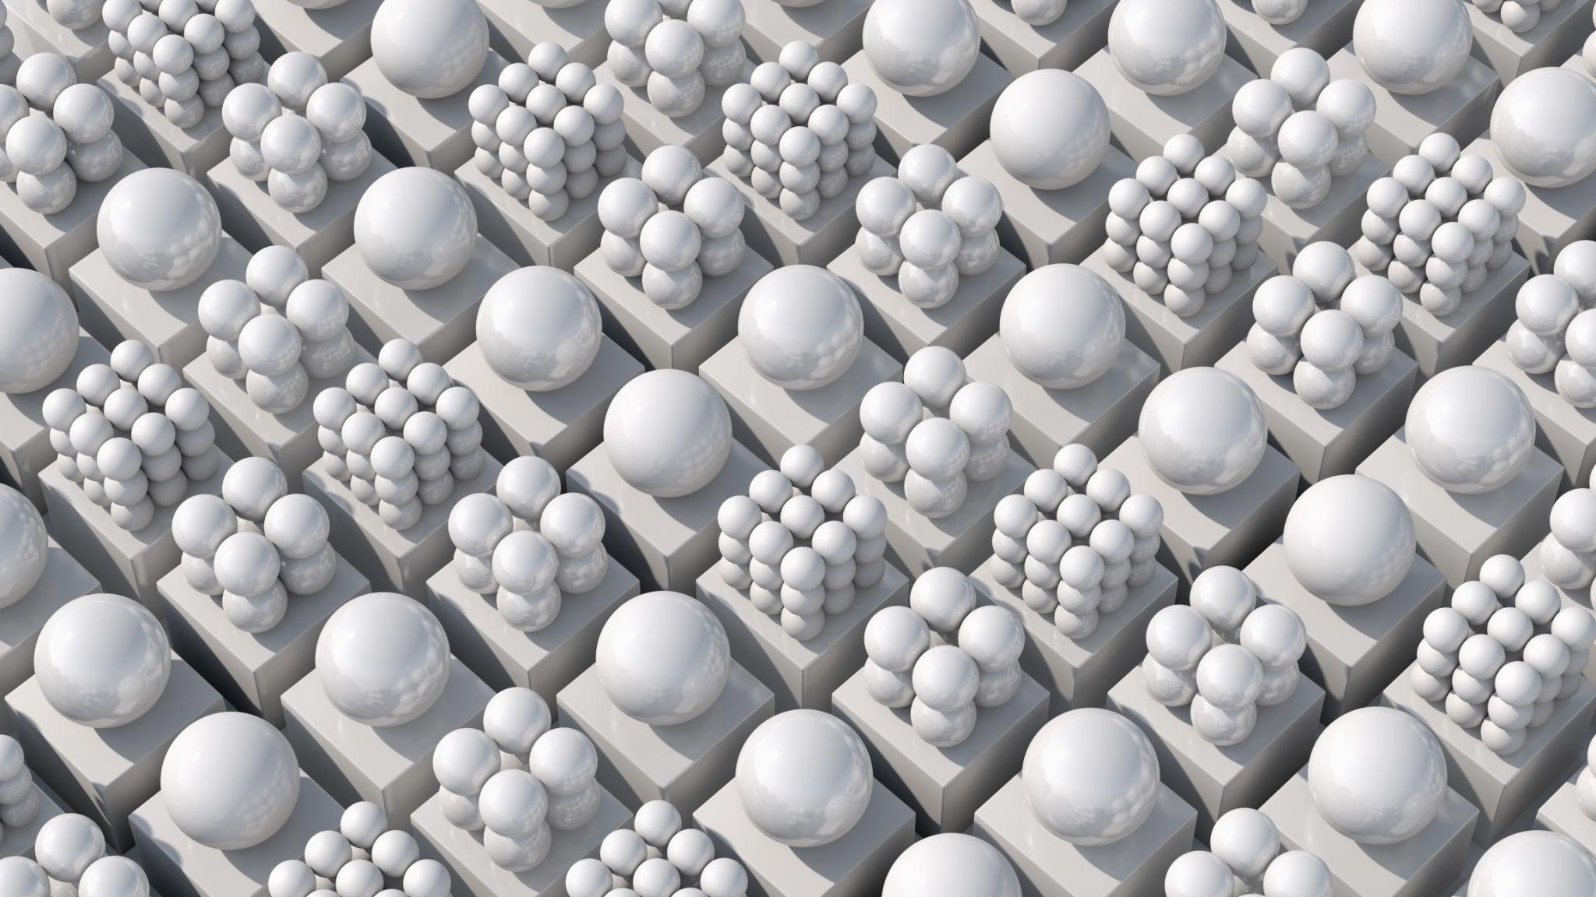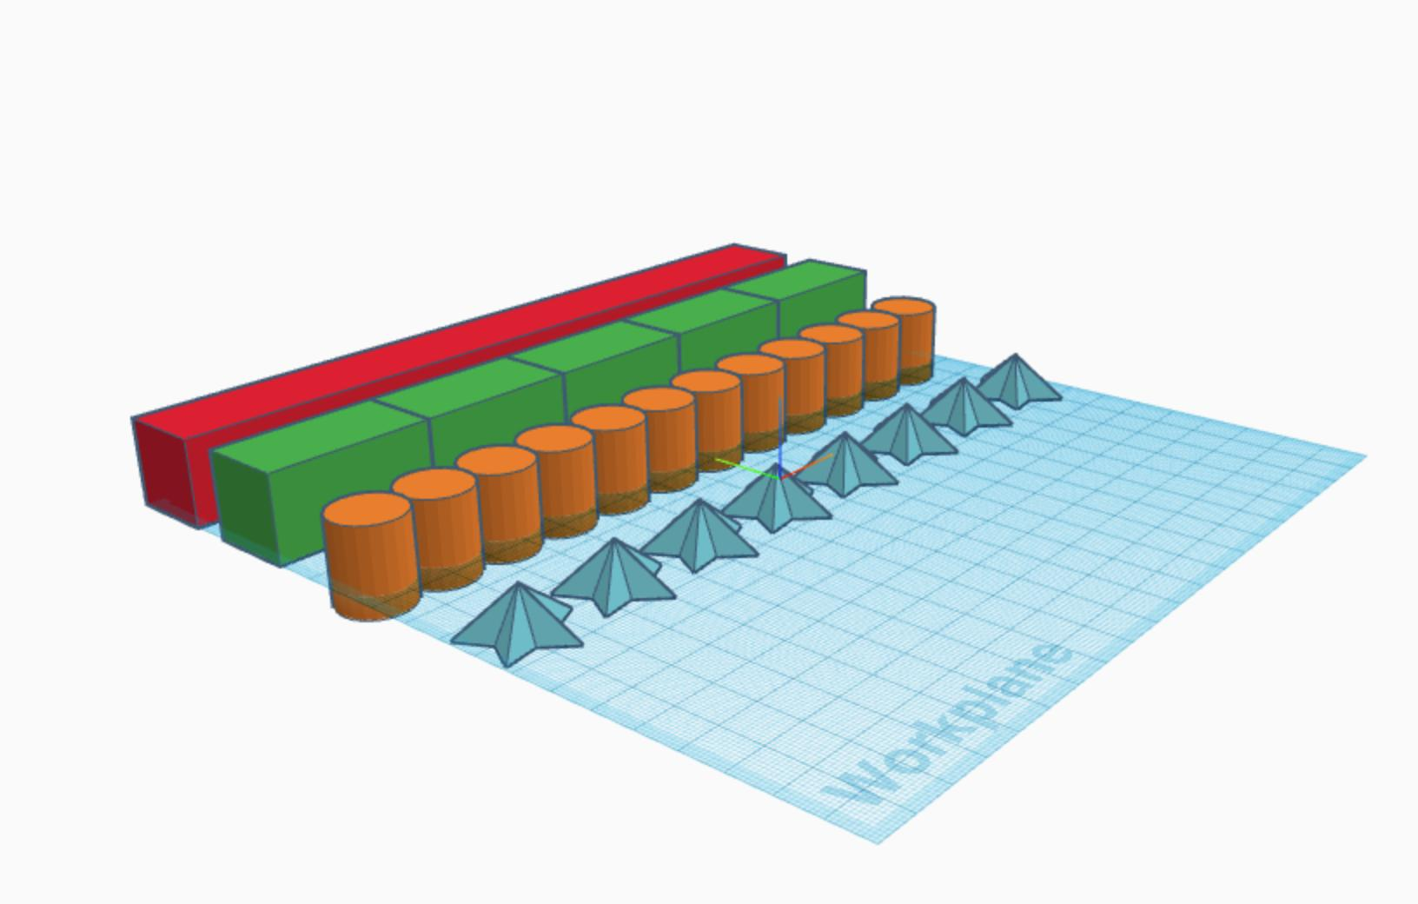
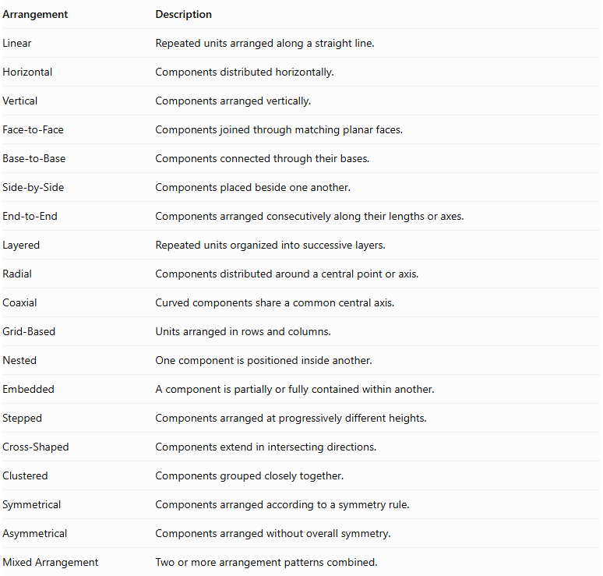
Arrangement | Description
Linear | Repeated units arranged along a straight line.
Horizontal | Components distributed horizontally.
Vertical | Components arranged vertically.
Face-to-Face | Components joined through matching planar faces.
Base-to-Base | Components connected through their bases.
Side-by-Side | Components placed beside one another.
End-to-End | Components arranged consecutively along their lengths or axes.
Layered | Repeated units organized into successive layers.
Radial | Components distributed around a central point or axis.
Coaxial | Curved components share a common central axis.
Grid-Based | Units arranged in rows and columns.
Nested | One component is positioned inside another.
Embedded | A component is partially or fully contained within another.
Stepped | Components arranged at progressively different heights.
Cross-Shaped | Components extend in intersecting directions.
Clustered | Components grouped closely together.
Symmetrical | Components arranged according to a symmetry rule.
Asymmetrical | Components arranged without overall symmetry.
Mixed Arrangement | Two or more arrangement patterns combined.

Classification by Surface Combination
# Source: AI Source: Provided by: [Data Path: Persons Table -> ID Column: 1, Name_En Column: Motasem Essam] -> From: [ChatGPT] on [7/25/2026]
Mixed-shape repeated composite solids can also be classified according to the surfaces present in their components.
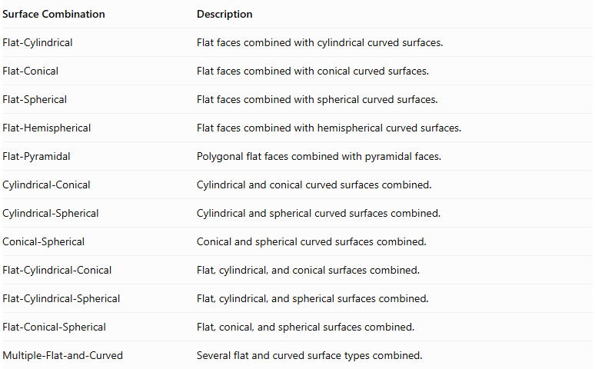
Surface Combination | Description
Flat-Cylindrical | Flat faces combined with cylindrical curved surfaces.
Flat-Conical | Flat faces combined with conical curved surfaces.
Flat-Spherical | Flat faces combined with spherical curved surfaces.
Flat-Hemispherical | Flat faces combined with hemispherical curved surfaces.
Flat-Pyramidal | Polygonal flat faces combined with pyramidal faces.
Cylindrical-Conical | Cylindrical and conical curved surfaces combined.
Cylindrical-Spherical | Cylindrical and spherical curved surfaces combined.
Conical-Spherical | Conical and spherical curved surfaces combined.
Flat-Cylindrical-Conical | Flat, cylindrical, and conical surfaces combined.
Flat-Cylindrical-Spherical | Flat, cylindrical, and spherical surfaces combined.
Flat-Conical-Spherical | Flat, conical, and spherical surfaces combined.
Multiple-Flat-and-Curved | Several flat and curved surface types combined.

Mathematical Properties and Formulas

Total Volume
# Source: AI Source: Provided by: [Data Path: Persons Table -> ID Column: 1, Name_En Column: Motasem Essam] -> From: [ChatGPT] on [7/25/2026]
The volume of a mixed-shape repeated composite solid is calculated by adding the volumes of its individual components when their interiors do not overlap.
$$\boxed{V_{total}=\sum_{i=1}^{n}{V_{i}}}$$
For repeated components:
$$V_{total}=n_{1}V_{1}+n_{2}V_{2}+⋯+n_{k}$$
Where:
- $n_{i}$ = Number of components of a particular type.
- $V_{i}$ = Volume of one component of that type.
- $k$ = Number of different component types.
If components overlap, the overlapping volume must be subtracted to avoid double-counting.

Volume Formulas for Component Solids
# Source: AI Source: Provided by: [Data Path: Persons Table -> ID Column: 1, Name_En Column: Motasem Essam] -> From: [ChatGPT] on [7/25/2026]
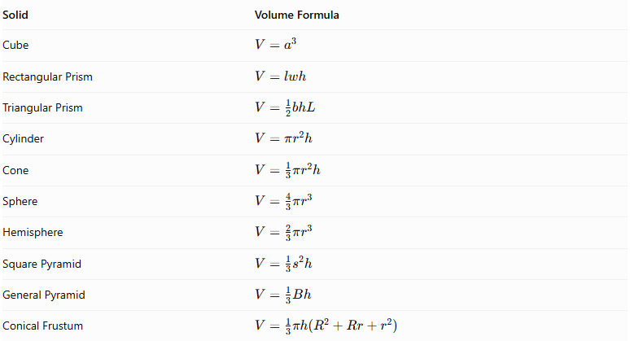
Solid | Volume Formula
Cube | $$V=a^{3}$$
Rectangular Prism | $$V=lwh$$
Triangular Prism | $$V=\frac{1}{2}bhL$$
Cylinder | $$V=πr^{2}h$$
Cone | $$V=\frac{1}{3}πr^{2}h$$
Sphere | $$V=\frac{4}{3}πr^{3}$$
Hemisphere | $$V=\frac{2}{3}πr^{3}$$
Square Pyramid | $$V=\frac{1}{3}s^{2}h$$
General Pyramid | $$V=\frac{1}{3}Bh$$
Conical Frustum | $$V=\frac{1}{3}πh(R^{2}+Rr+r^{2})$$

External Surface Area
# Source: AI Source: Provided by: [Data Path: Persons Table -> ID Column: 1, Name_En Column: Motasem Essam] -> From: [ChatGPT] on [7/25/2026]
The external surface area is the sum of all surfaces that remain exposed after the components are joined.
$$\boxed{{SA}_{external}=Total exposed surface area}$$
For components connected through complete matching planar faces:
$${SA}_{external}=\sum{{SA}_{i}}-2\sum{A_{contact}}$$
Where:
- ${SA}_{i}$ = Total surface area of each separate component.
- $A_{contact}$ = Area of each complete joining interface.
For partial or curved contact, calculate the actual hidden surface regions rather than subtracting an entire face.

Surface Area Formulas for Component Solids
# Source: AI Source: Provided by: [Data Path: Persons Table -> ID Column: 1, Name_En Column: Motasem Essam] -> From: [ChatGPT] on [7/25/2026]
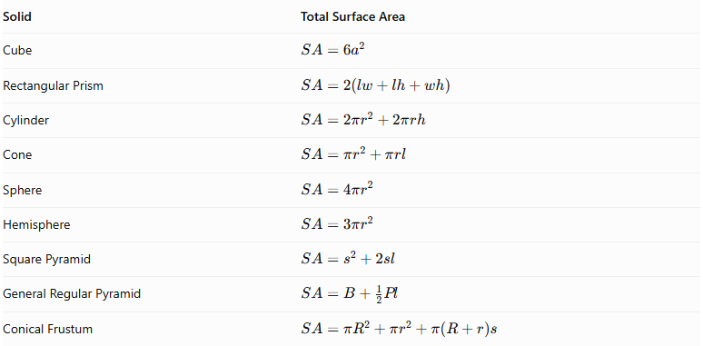
Solid | Total Surface Area
Cube | $$SA=6a^{2}$$
Rectangular Prism | $$SA=2(lw+lh+wh)$$
Cylinder | $$SA=2πr^{2}+2πrh$$
Cone | $$SA=πr^{2}+πrl$$
Sphere | $$SA=4πr^{2}$$
Hemisphere | $$SA=3πr^{2}$$
Square Pyramid | $$SA=s^{2}+2sl$$
General Regular Pyramid | $$SA=B+\frac{1}{2}Pl$$
Conical Frustum | $$SA=πR^{2}+πr^{2}+π(R+r)s$$
For a right circular cone:
$$l=\sqrt{r^{2}+h^{2}}$$
For a right circular frustum:
$$s=\sqrt{h^{2}+(R-r)^{2}}$$
Where:
- $l$ = Cone slant height.
- $s$ = Frustum slant height.
- $R$ = Larger radius.
- $r$ = Smaller radius.
- $P$ = Perimeter of the pyramid base.
- $B$ = Area of the pyramid base.

Worked Examples

Example 1: Repeated Units of a Rectangular Prism, Cylinder, and Cone
# Source: AI Source: Provided by: [Data Path: Persons Table -> ID Column: 1, Name_En Column: Motasem Essam] -> From: [ChatGPT] on [7/25/2026]
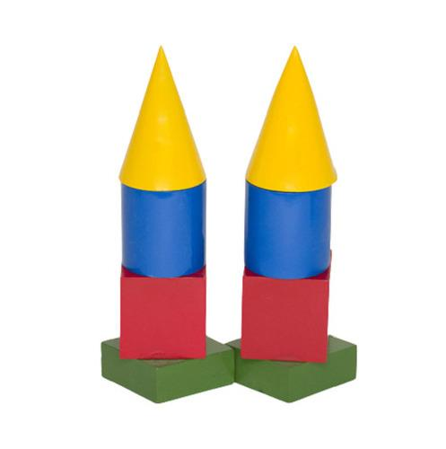
A structure contains three identical units. Each unit consists of:
- A rectangular prism with dimensions $6×6×4 cm$.
- A cylinder with radius $2 cm$ and height $5 cm$.
- A cone with radius $2 cm$ and height $3 cm$.
The cylinder is placed on the prism, and the cone is placed on the cylinder. The circular bases fit within the prism's square top face.
Step 1: Calculate the volume of one rectangular prism.
$$V_{1}=lwh$$
$$V_{1}=6×6×4$$
$$V_{1}=144{ cm}^{3}$$
Step 2: Calculate the volume of one cylinder.
$$V_{2}=πr^{2}h$$
$$V_{2}=π(2)^{2}(5)$$
$$V_{2}=20π{ cm}^{3}$$
Step 3: Calculate the volume of one cone.
$$V_{3}=\frac{1}{3}πr^{2}h$$
$$V_{3}=\frac{1}{3}π(2)^{2}(3)$$
$$V_{3}=4π{ cm}^{3}$$
Step 4: Calculate the volume of one complete unit.
$$V_{unit}=144+20π+4π$$
$$V_{unit}=144+24π$$
Step 5: Calculate the total volume of three units.
$$V_{total}=3(144+24π)$$
$$\boxed{V_{total}=432+72π}$$
$$\boxed{V_{total}≈658.19{ cm}^{3}}$$
Step 6: Calculate the external surface area of one unit.
Rectangular prism surface area:
$${SA}_{1}=2(6×6+6×4+6×4)$$
$${SA}_{1}=168{ cm}^{2}$$
The circular contact between the prism and cylinder hides one circular region of area $4π$. The cylinder's top base is hidden by the cone, while its curved surface remains exposed.
Cylinder curved surface area:
$${CSA}_{2}=2πrh=2π(2)(5)=20π$$
Cone slant height:
$$l=\sqrt{2^{2}+3^{2}}=\sqrt{13}$$
Cone curved surface area:
$${CSA}_{3}=πrl=2π\sqrt{13}$$
Therefore:
$${SA}_{unit}=168-4π+20π+2π\sqrt{13}$$
$${SA}_{unit}=168+16π+2π\sqrt{13}$$
For three separate units:
$${SA}_{total}=3(168+16π+2π\sqrt{13})$$
$$\boxed{{SA}_{total}=504+48π+6π\sqrt{13}}$$
$$\boxed{{SA}_{total}≈660.94{ cm}^{2}}$$
<badge color="success">Final Answer</badge>
- Total Volume = $432+72π≈658.19{ cm}^{3}$
- Total External Surface Area = $504+48π+6π\sqrt{13}≈660.94{ cm}^{2}$

Example 2: Repeated Units of a Cylinder, Hemisphere, and Cone
# Source: AI Source: Provided by: [Data Path: Persons Table -> ID Column: 1, Name_En Column: Motasem Essam] -> From: [ChatGPT] on [7/25/2026]
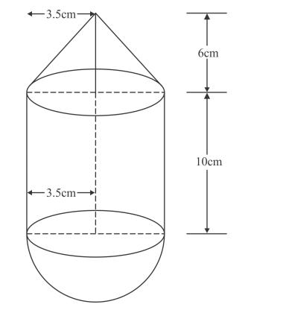
A structure contains two identical units. Each unit consists of:
- A cylinder with radius $3 cm$ and height $6 cm$.
- A hemisphere with radius $3 cm$ attached to the bottom of the cylinder.
- A cone with radius $3 cm$ and height $4 cm$ attached to the top of the cylinder.
All three components share matching circular joining bases.
Step 1: Calculate the volume of one cylinder.
$$V_{1}=πr^{2}h$$
$$V_{1}=π(3)^{2}(6)=54π$$
Step 2: Calculate the volume of one hemisphere.
$$V_{2}=\frac{2}{3}πr^{3}$$
$$V_{2}=\frac{2}{3}π(3)^{3}=18π$$
Step 3: Calculate the volume of one cone.
$$V_{3}=\frac{1}{3}πr^{2}h$$
$$V_{3}=\frac{1}{3}π(3)^{2}(4)=12π$$
Step 4: Calculate the volume of one complete unit.
$$V_{unit}=54π+18π+12π$$
$$V_{unit}=84π$$
Step 5: Calculate the total volume of two units.
$$V_{total}=2(84π)$$
$$\boxed{V_{total}=168π≈527.79{ cm}^{3}}$$
Step 6: Calculate the external surface area of one unit.
Cylinder curved surface area:
$${CSA}_{1}=2πrh=2π(3)(6)=36π$$
Hemisphere curved surface area:
$${CSA}_{2}=2πr^{2}=18π$$
Cone slant height:
$$l=\sqrt{3^{2}+4^{2}}=5$$
Cone curved surface area:
$${CSA}_{3}=πrl=π(3)(5)=15π$$
All joining circular bases are hidden, so only the curved surfaces are exposed.
$${SA}_{unit}=36π+18π+15π$$
$${SA}_{unit}=69π$$
For two units:
$${SA}_{total}=2(69π)$$
$$\boxed{{SA}_{total}=138π≈433.54{ cm}^{2}}$$
<badge color="success">Final Answer</badge>
- Total Volume = $168π≈527.79{ cm}^{3}$
- Total External Surface Area = $138π≈433.54{ cm}^{2}$

Important Characteristics
# Source: AI Source: Provided by: [Data Path: Persons Table -> ID Column: 1, Name_En Column: Motasem Essam] -> From: [ChatGPT] on [7/25/2026]
- They contain two or more different categories of geometric solids.
- Their components are arranged in repeated units or recurring patterns.
- Each repeated unit may contain two, three, or more solid types.
- Components may have equal or different dimensions.
- The arrangement may be linear, vertical, horizontal, radial, layered, or grid-based.
- They combine flat, curved, conical, cylindrical, spherical, and polygonal surfaces.
- Their volume is calculated by combining component volumes, with overlap corrections when necessary.
- Their external surface area includes only exposed surfaces.
- Joining interfaces become internal and must be excluded from external surface-area calculations.
- Their overall shape may be symmetrical, asymmetrical, regular, or irregular.

Comparison with Other Repeated Composite Solids
# Source: AI Source: Provided by: [Data Path: Persons Table -> ID Column: 1, Name_En Column: Motasem Essam] -> From: [ChatGPT] on [7/25/2026]
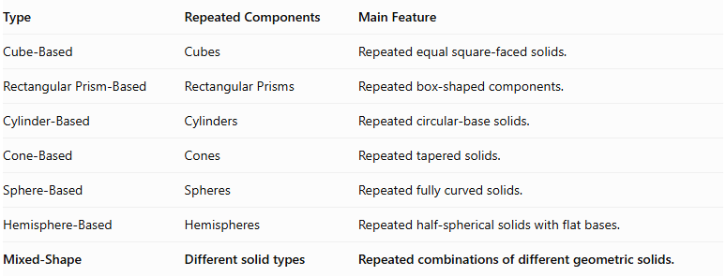
Type | Repeated Components | Main Feature
Cube-Based | Cubes | Repeated equal square-faced solids.
Rectangular Prism-Based | Rectangular Prisms | Repeated box-shaped components.
Cylinder-Based | Cylinders | Repeated circular-base solids.
Cone-Based | Cones | Repeated tapered solids.
Sphere-Based | Spheres | Repeated fully curved solids.
Hemisphere-Based | Hemispheres | Repeated half-spherical solids with flat bases.
Mixed-Shape | Different solid types | Repeated combinations of different geometric solids.

Applications
# Source: AI Source: Provided by: [Data Path: Persons Table -> ID Column: 1, Name_En Column: Motasem Essam] -> From: [ChatGPT] on [7/25/2026]
- Architecture: Repeated structures combining columns, domes, pyramids, and other solid forms.
- Construction: Repeated structural units containing different geometric components.
- Mechanical Engineering: Components assembled from cylindrical, conical, and prismatic parts.
- Industrial Design: Products containing repeated combinations of different solid shapes.
- Product Design: Repeated housings, supports, and decorative structures.
- Manufacturing: Modular parts made from different geometric components.
- Computer Graphics: Modeling complex repeated three-dimensional objects.
- Mathematics Education: Studying composite volumes, surface areas, and spatial arrangements.

Key Points
# Source: AI Source: Provided by: [Data Path: Persons Table -> ID Column: 1, Name_En Column: Motasem Essam] -> From: [ChatGPT] on [7/25/2026]
- Mixed-Shape Repeated Composite Solids combine different geometric solid types in recurring arrangements.
- They can contain two, three, four, or more solid categories.
- Common combinations include prism-cylinder, prism-cone, cylinder-sphere, cylinder-cone, and multi-type combinations.
- Their arrangements may be linear, vertical, horizontal, radial, layered, grid-based, or clustered.
- Total volume is the sum of component volumes when there is no overlap.
- Overlapping regions must be corrected to avoid double-counting.
- External surface area includes only exposed surfaces.
- Hidden joining surfaces must be excluded from external surface-area calculations.
- These structures are useful in architecture, engineering, manufacturing, product design, and computer graphics.

Conclusion
# Source: AI Source: Provided by: [Data Path: Persons Table -> ID Column: 1, Name_En Column: Motasem Essam] -> From: [ChatGPT] on [7/25/2026]
Mixed-Shape Repeated Composite Solids represent a broad category of three-dimensional structures formed by repeatedly combining different geometric solid types.
Unlike single-shape repeated composite solids, they contain multiple categories of components, allowing more complex arrangements and surface combinations. Their mathematical analysis depends on the dimensions, number, arrangement, and connection of the individual components.
Understanding their component volumes and exposed surfaces provides the foundation for calculating their total volume and external surface area accurately.

